Contents
Questions 2
Why Data need to be converted to binary to be processed by computers? 2
Overflow error in addition of binary number. 2
Q1. Can you think of three examples of analogue data? 2
Q2. Why is analogue data described as continuous data? 2
Q4. Add the 8-bit values 00100110 and 01010111. 3
Q5. Describe what happens in a logical binary shift. 3
Q6. Perform two logical shift to the right on the binary number 11101100 3
Q7. Why do you think lossy compression is not commonly used on text files? 3
Q8. Will lossy compression affect the quality of an image? Why? 3
Q9. Will lossy compression affect the quality of a sound? Why? 3
Activities 4
Activity 1.1 4
ACTIVITY 1.2 5
ACTIVITY 1.3 7

Questions

Why Data need to be converted to binary to be processed by computers?
Data need to be converted to binary to processed by computer. Computer don't understand the Human languages, images video or any kind of data, the only understandable language for Computer is binary which is also called machine language. This binary number grouped together and form an instruction that executed by the central processing unit (CPU) directly. That is why data need to That be is converted to binary for Processing.

Overflow error in addition of binary number.
During addition an overflow error is occur because of larger value then the memory can store. For example, adding two 8-bit binary number whose result is greater than 255 will throw an error of overflow.
11001010
+ 01110111
101000001

Q1. Can you think of three examples of analogue data?
Answer. Three different examples of analogue data:
- Hearing: Hearing sound is an example of analogue data because we hear the data continuously without any discretion.
- Watching: Everything we see is analogue data decoding by our brain and give us the vision information.
- Touching: while touching anything out skin send analogue data to brain which decode it and tell us what we are touching.

Q2. Why is analogue data described as continuous data?
Answer. All the operations done by analogue data, receive the data without any discretion. Analogue data give us infinite number of potential values between two number/range that is why analogue data is described as continuous data.
Q3. Add the 8-bit values 00011001 and 01000011.
00011001
+ 01000011
01111100

Q4. Add the 8-bit values 00100110 and 01010111.
01010111
+ 00100110
01111101

Q5. Describe what happens in a logical binary shift.
Answer: Computer used binary shift: left shift and right shift, to perform multiplications and divisions. The logical left shift multiply the value while the logical right shift divide the value. The numbers of shifts decide how many times the value has to multiply or divide.

Q6. Perform two logical shift to the right on the binary number 11101100
Answer:
1 | 1 | 1 | 0 | 1 | 1 | 0 | 0
- | - | 1 | 1 | 1 | 0 | 1 | 1

Q7. Why do you think lossy compression is not commonly used on text files?
Answer: Lossy compression uses the algorithms that permanently remove the redundant or unnecessary data. In the case of text files compression, the lossy compression when remove the repeated text which will corrupt the file that is why lossy compression is not used to compressed the text file.

Q8. Will lossy compression affect the quality of an image? Why?
Answer: Yes, the lossy compression will permanently affect the image quality. The lossy compression removes the data permanently which will not be decode in the decompression time and the image quality will be affect because the lossy compression affects the resolution/color depth of an image.

Q9. Will lossy compression affect the quality of a sound? Why?
Answer: Yes, because the repeated sample rate will be permanently deleted while compression.

Activities

Activity 1.1
Each computer has a MAC address. This MAC address is written in hexadecimal. This is one of the ways that hexadecimal is used in computer science. Use the internet to find three more uses of hexadecimal in computer science

Uses of Hexadecimal in Computer Science

Hexadecimal is a number system base of "16" instead of base 2 binary as binary which include only two numbers 0 and 1 or base 10 of denary/decimal which starts from 0-9. Hexa-decimal numbers use the base 16 which include numbers 0-9 with addition of English alphabets A- F. It provides a bridge to read binary numbers easily.
Comparison of denary and Hexadecimal
1 | 2 | 3 | 4 | 5 | 6 | 7 | 8 | 9 | 10 | 11 | 12 | 13 | 14 | 15 | 16
0 | 1 | 2 | 3 | 4 | 5 | 6 | 7 | 8 | 9 | A | B | C | D | E | f

→Three different usages of Hexadecimal Computer Science.

1. Color Representation; Most of the computer languages such JavaScript, C#, Java, Python, Swift and so on use hexa-decimal numbers to represent Colors. For Example, HTML and CSS using the 6-digit RGB (Red, Green, Blue) codes, #FFFFFF used for white color.

2. IPv6 Addressing; Computer Networks provide unique Internet protocol (IP) address for each connected device. Unlike the IPv4 Which uses four decimal number by separated by a dot, totel 32 in number (1001.1111.1010.1110.0010.0011.1111.0000), IPv6(Internet Protocol version 6) uses eight group of 4 hexadecimal numbers separated by colons which covers 128 bits for a single unique IP address. For example,
2001:0db8:85a3:0000:0000:8a2e:0370:7334
3. Debugging; Debugging is the process of finding, understanding and Fixing problems/errors in codes. Hexa-decimals are used in several debugging Processes like Memory addressing, identify memory errors and Inspecting registers.
A special type of variable called pointers use stores memory addresses for other elements. Instead of to binary, it uses hexadecimal to display the memory address which is easily readable for coders the identity The memory addressing. In the memory a single address is shown in 64-bit long binary while hexa-decimal compacts this large sequence to only 16 characters.
When a memory point is crashed or filled uninitialized Operating system Identify it with a hexa-decimal number. For example, 0x00000000" points to null pointer.
A 64 bit register stores 64 bit of data. For example, inspecting that register will show the sequence of 64 0s and 1s
(11010010 01101001 10010110 11010100 00101011 11001010 01011001 10101001) the problem introduced here the sequence of 64 0s and 1s is very hard to understand fast, by using Hexa-decimal These 64 bits are compressed to 16 character only
5D4F:9A2E:1B3C:8E70

ACTIVITY 1.2

Use the internet to find an example of an ASCII character set and a Unicode character set. What kind of different characters are represented? Are upper and lowercase letters the same? Using the ASCII table, try to decode this message:
010000110110111101001101011100000111010101110100011001010111001001010011011000110110100101000101011011100110001101100101011010010111001101100110011101010110111000100001
Remember, each letter will be represented as an 8-bit binary number.
Try writing a message for your friend to decode.
The ASCII codes for upper- case and lower-case alphabets are different.
Decoding the given binary by 8-bit
Binary | Denary | ASCII valude
01000011 | 67 | C
01101111 | 111 | o
01001101 | 77 | M
01110000 | 112 | p
01110101 | 117 | u
01110100 | 116 | t
01100101 | 101 | e
01110010 | 114 | r
01010011 | 83 | S
01100011 | 99 | c
01101001 | 105 | i
01000101 | 69 | E
01101110 | 110 | n
01100011 | 99 | c
01100101 | 101 | e
01101001 | 105 | i
01110011 | 115 | s
01100110 | 102 | f
01110101 | 117 | u
01101110 | 110 | n
00100001 | 33 | !
CoMputerSciEnceisfun!
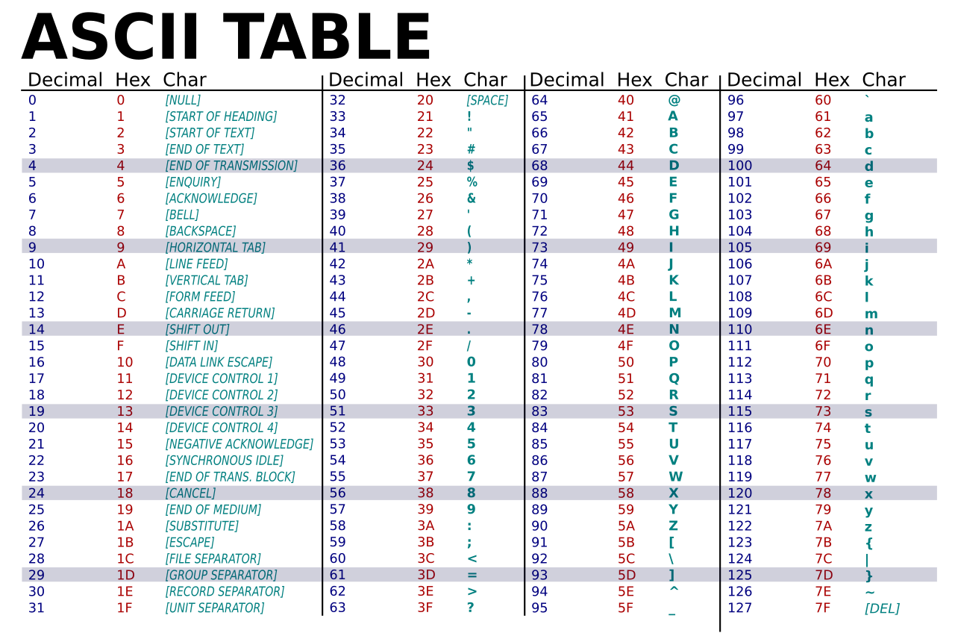

ACTIVITY 1.3
Use the internet to find an RGB color scale. You should notice that each color in the scale is first presented as hexadecimal. The first two hexadecimal values are the amount of red, the second two the amount of blue and the last two the amount of green.

Practice your hexadecimal to binary conversion by converting your favorite color to its binary value.

Favorite color: Light Pink
RGB value of Light Pink: f4aeba
Binary value of f4aeba 1111 0100 1010 1110 1011 1010

